





















Submission
Senate Inquiry on the NDIS Amendment (Securing the NDIS for Future Generations) Bill 2026



Down Syndrome NSW (DSNSW) is aware that the intended purpose of the NDIS Amendment (Securing the NDIS for Future Generations) Bill 2026 is to progress the identified government priorities of
- Finding, fighting and preventing fraud
- Slowing rapid cost growth
- Clarifying eligibility
Improving quality and consistency of supports.
The stated aim of the Bill is to address these priorities by working to
- slow spending growth,
- tighten eligibility,
- clarify what the NDIS funds,
- strengthen fraud controls,
- improve provider quality, and
- standardise the planning system.
DSNSW asserts that the proposed changes to the NDIS are budget-driven and will have a significant adverse impact on people with Down syndrome and their families and supporters. The changes in the Bill as currently drafted, endanger outcomes for people with Down syndrome and will displace their disability support needs rather than address them.
Further the changes diminish systemic oversight and access to independent evaluation of public service decision-making and procedural fairness. Systemic oversight and independent evaluation are essential to remedy mistakes which can have significant impact for individual safety and wellbeing.

Eligibility for the NDIS
For eligibility, the original intent of the NDIS rightly focussed on assessing the day-to-day reasonable supports required for a person with disability to live an ordinary life, rather than solely identifying the diagnosis.

This recognises that people with disability, like people without disability, are individuals with rights, varying personal histories, cultural backgrounds, home community social capital, family situations, life circumstances, talents, attributes and aspirations.

The original intent of the NDIS recognised that people sharing the same diagnosis, such as Down syndrome, could have varied co-occurring impairments and conditions. These are known to be more common with Trisomy 21, who can experience widely differing support needs, which can change significantly across life stages.

Functional Capacity
DSNSW is alarmed that the proposed formal definition of ‘functional capacity” will not include appropriate and due consideration of a person’s personal and environmental circumstances.

While strengthening the NDIS focus on impairments, this Amendment Bill minimises considerations of a person’s life circumstances and all the other interacting factors that affect a person’s capacity to live an ordinary life.
No person is their disability. Like other people, people with Down syndrome and intellectual disability are affected by their relationships (if any), their living situations, the environment and community that surrounds them as well as their own hopes, talents, aspirations and goals. Failure to integrate these real world complexities for people with Down syndrome will leave some at risk of inadequate support for day to day survival. This will likely result in recurring cycles of crisis, consequent cost shifting to other systems, and the likely premature need for Supported Independent Living (SIL) supports.
Any assessment of functional capacity that ignores all these factors will be a deficit-based approach that reduces the person solely to their disability. This will also standardise “functional capacity” in ways that are very unlikely to provide supports that respond to individual real world needs, and hence endanger outcomes.
DSNSW asserts that in line with the evidence-based WHO biopsychosocial model, integrating the real-world complexities for people with Down syndrome, and other disabilities, is essential for adequate understanding of their real-world disability-related support needs. Failure to do so will endanger outcomes.

Considering Life Circumstances
Further, there is real danger in ignoring the circumstances of a person’s life for eligibility and assessments as this form of standardisation can result in under-servicing (or even over-servicing) that will limit opportunity and will transfer the provision of disability support to families with varying capacity to manage.

Interpreting Eligibility Criteria
At the inception of the NDIS, the eligibility criteria centred on permanence, significant needs for daily living, and inclusion. However, over time it appears that these criteria have been applied differently by NDIA officers and planners.

This is not the fault or responsibility of people with disability but rather a scheme implementation and administration issue. The proposed legislation is unlikely to resolve these implementation and administration issues and may exacerbate them.

Permanence, Treatment and Reassessment
DSNSW is aware the intention of proposed Amendments is for
- more consistent and tightened assessments of permanence,
- consideration of available treatments, and
- reassessment processes for some participants.

Considering Permanence
The Bill as drafted proposes that participants must show they have undertaken “all appropriate treatment” before impairments can be considered permanent. This is unreasonable where a participant cannot practically access a treatment due to location or ability to pay, or where the treatments involve risk to the participant’s rights of consent and bodily autonomy.

The Bill as drafted has insufficient guardrails for ensuring basic rights and so could readily lead to systemic coercion of people with disabilities to undertake:
- treatments not in keeping with their own values,
- costly treatments that divert their limited incomes away from essential living costs,
- time-consuming treatment that inhibits their capacity to do other activities of an ordinary life
- treatments that are physically or psychologically invasive, and that they do not wish to undertake.
This change will cause excessive demand on already stretched systems by adding people to waitlists who are going through treatment simply to demonstrate they tried “all appropriate treatments”, rather than having a real likelihood of significant enough change in functional capacity to alter their NDIS eligibility.

For people with Down syndrome, a requirement to exhaust treatments will delay entry to the NDIS for a cohort with lifelong needs, for whom the NDIS was clearly intended. Further, delaying access to NDIS supports for social inclusion and ordinary community participation risks medicalising and pathologizing the lives of young people with Down syndrome in ways that negatively impact development of healthy identity and self-esteem. It risks reinforcing the outdated discredited ‘medical model’, thereby imposing a destructive message that people with Down Syndrome must try to be ‘fixed’, try to be like non-disabled peers, before they can be valued enough to be supported to live an ordinary life. People with Down syndrome have the right to an ordinary life as a child, young person and young adult, older adult and not to be forced into a hot-housed life dominated by ‘treatments’.

In raising their child, families with a child with Down syndrome have the right to make decisions and set priorities that are in line with their values. Families should not be forced to access essential government support that coerces prioritising treatments over other childhood and family life experiences for health and wellbeing. This proposed NDIS change is disrespectful, unreasonable for people with Down syndrome and will likely result in higher downstream costs in mental health, behaviour support and premature need for SIL 24/7 support.

DSNSW recommends a direct timely pathway into the NDIS for people with Down syndrome because Down syndrome is a lifetime chromosomal condition for which pursuit of ‘all appropriate treatments’ will not change their subsequent eligibility for the NDIS.

Access to Available Treatments
When considering ‘available treatments’ for potential participants, the government must recognise that people with Down syndrome and other intellectual disability have been historically and routinely excluded from many of the ‘available treatments’ simply due to assumptions about their disability rather than their actual need.

These treatments delivered by other service systems to the whole population e.g., Health, are ill-equipped to deliver the highly specialised evidence-based treatments effective for outcomes with the small target population of people with Down syndrome. For example, speech therapy integrated simultaneously with key word signing and early literacy support is significantly more effective for speech, language development and functional communication skills in people with Down syndrome than standard speech therapy approaches.

Research shows that people with Down syndrome will continue to build basic developmental skills over their lifetime, not just concentrated in childhood. Accordingly, these specialised treatments must be available across the lifespan. The Amendments must not assume that other service systems are immediately available to people with disability simply because the NDIS has changed its access requirements. If adverse impacts are to be avoided, there must be firm agreements in place with state and territory governments and with professional bodies before any change to the NDIS is considered.

Amendment Bill reforms must not wind back access to essential NDIS treatments and supports that have enabled people with Down syndrome and intellectual disability to live healthy ordinary lives.

Mistaken Focus on Deficits
The Bill proposal that NDIS support is limited to “needs directly arising from the qualifying impairment” is highly problematic if applied to people with Down syndrome. There are multiple interacting impairments (intellectual, cognitive, neurological, physical, sensory) that may impact an individual with Down syndrome including some that emerge more often with age.

Under the current draft of the Bill people with Down syndrome would have to jump through separate hoops to have all these impairments included in their impairment notice as qualifying, and somehow separately assign their intersecting and interacting support needs to each impairment. This requirment is unreasonable and ill-conceived for application to people with Down syndrome.

In the past before the NDIS, eligibility for services and supports has focussed on addressing the person’s deficits and ignored the potential and right of the person with Down syndrome and intellectual disability to live an ordinary life, like others around them.

From a budget perspective, actuarial costings for the introduction of the NDIS demonstrated that the costs of supporting people to live an ordinary life under the NDIS are far outweighed by the costs of people with Down syndrome and intellectual disability without appropriate supports, being unnecessarily and prematurely channelled into other very restrictive high support needs services. Nobody wins when this happens.

Narrowing NDIS Supports
Most people with Down syndrome rely on lifelong supports across many aspects of life, including communication, supported decision-making, activities of daily living, employment, social participation, transport, therapy, and community inclusion.
DSNSW members worry that the Bill reframes many of these supports as:
- “non-essential,”
- “lifestyle” supports, or
- supports that should be provided by families or mainstream systems instead of the NDIS.
This is especially concerning because many people with Down syndrome rely heavily on supports that build independence and community participation to live an ordinary life consistent with their rights under the UNCRPD.
Reducing these NDIS supports will transfer disability support tasks to families, mostly to women. It will have significant impact on their capacity to work, to meet family costs of living, to meet the needs of other family members such as ageing parents or younger siblings, and will impact the health and wellbeing of people with Down syndrome and carers. For people with Down syndrome without family and/or personal networks, the loss of these supports can be even more debilitating.

Reducing Social Inclusion
Social and community participation are essential to a healthy, inclusive and connected life.

People with Down syndrome and families fear that cuts to social and community participation will cause harm. One of the strongest reactions among people with Down syndrome and families relates to the Bill’s proposed “resetting” cuts to
- budgets for social participation,
- community access supports, and
- some capacity-building supports.

For many people with Down syndrome, Social and Community Participation supports are critical to making an ordinary life possible:
- joining clubs where a sense of belonging is built with others locally who have similar interest and values,
- participating in religious and cultural practices
- learning life skills,
- volunteering,
- attending TAFE,
- participating in sport, and other regular healthy physical activities
- developing and maintaining friendships and personal relationships, and
- building confidence and independence.
These are not optional extras. They are integral to the daily functioning of people with Down syndrome and intellectual disability, and are generally considered be social determinants of health and wellbeing. Going to group disability programs and activities with co-participants does not address these important social determinants of health and wellbeing. Social and community supports for meaningful inclusion and genuine connections can serve to prevent loneliness, segregation and dependence, which otherwise would result in serious and expensive health and psychological impacts on the person.
DSNSW joins with other advocates who consider that these proposed reforms undervalue the right to and importance of social inclusion for people with intellectual disability. DSNSW strongly opposes this as it unfairly and disproportionately impacts people with Down syndrome.
An article, co-authored by a DSNSW member titled “Cutting NDIS Social and Community Participation May Save Money – or Might it Risk Creating Bigger Costs for other Government Agencies” has been included at the end of this submission.

Downgrading Social and Community Participation
The Explanatory Memorandum acknowledges that reductions to Social and Community Participation will reduce access to the community for people with disability.
In response, the Government says the impact on people with disability may be mitigated because
- participants can use their Core funding more flexibly.
DSNSW argues that if funding for Social and Community Participation is reduced, a participant’s existing Core funding will not suddenly stretch to cover their necessary inclusion in the community. This proposal unfairly places people with Down syndrome in a position of having to choose between getting out into their community and having friends or receiving the basic daily living supports like personal hygiene, modified food management, medication management.
These choices are not real nor reasonable, and either way will impact health and wellbeing and cause consequent downstream costs.
- participants may shift from 1:1 supports to lower cost group activities
A shift to low cost group activities by congregating NDIS participants together for cheaper support makes the false assumption that activity groups with other people with disabilities is an effective substitute for meaningful social inclusion. It also supports an outdated ill-conceived view that this is simply about occupying participants’ time.
The benefits of meaningful social and community inclusion will be lost. For example a young man with Down syndrome who is supported to join in, as a member, at his local Men’s Shed reaps far more in outcomes than the same young man going to a group disability provider program that has a woodwork instructor coming into the group. DSNSW argues that some people with Down syndrome cannot “choose” to shift away from 1:1 (or more intensive) supports to group activities due to the complexity of their disability and its impacts.
For some people with Down syndrome with co-occurring related conditions, group activities could actually be triggering and harmful to both the person and others around them. This segregating proposal also unfairly restricts people with Down syndrome to having social and community connections with others with disabilities with similar needs, and subsequently inhibits the formation of meaningful local informal supports.
- the proposed $200 million Inclusive Communities Fund is intended to expand community-based inclusion options.

DSNSW contends that the Inclusive Communities Fund is to date only an intention, and details about its implementation and availability are at present unclear.
Without further details and firm commitments, people with Down syndrome and families are justifiably very anxious (frightened) that there will be a return to the past where isolation and segregation were the norm for people with disability, and the impacts for health, wellbeing and life expectancy were very poor.
Since the announcement, families have reached out to us to tell us what these cuts could mean to them. We have included some of these comments at the end of the submission.

Increased Reliance on Supports Outside the NDIS
The Bill places greater emphasis on assumed informal supports, perceived family responsibility, and the willingness and availability of mainstream systems.
DSNSW is very concerned because the NDIS originally promised to move away from systems where families alone carried most of the responsibility, particularly for adults.
As people with Down syndrome grow older, their parents are also ageing. With non-institutionalised living and effective early supports, it is becoming far more common for people with Down syndrome to outlive their parents. Increasingly, there is realistic fear about:
- what happens when the parents become incapacitated or die,
- whether siblings will be expected to fill gaps in disability support, with consequent reduced availability for the sibling’s own children as well as the needs of the ageing parents, and
- whether reduced supports will force families back into crisis caring roles and out of workforce participation. This will disproportionately impact women who most often are expected to take up the unpaid caring roles.
Some people with Down syndrome continue to live with ageing parents. This combined with the proposed reduction in social and community participation funding will mean the adults with Down syndrome are not getting the vital opportunities to experientially learn they can have a life beyond their parents and to build necessary skills and emotional adjustment for a successful healthy life independent of parents. Consequently, parents are worried about what will happen to the person with Down syndrome when they can no longer provide care and support, and the likelihood the person with Down syndrome will experience overwhelming crisis rather than appropriately supported smooth transition to life beyond parental dependency.
Many siblings will have grown up with their person with Down syndrome and have gone on to build lives of their own including families and careers. With housing cost pressures, siblings are more likely to live a distance from parents. Consequently, siblings may not be in a position to take on a significant caring role for their person with Down syndrome. This is not a reasonable or desirable option. Creating a NDIS system through legislation that assumes family capacity, availability and willingness to fill gaps in disability related support of adults is ill-conceived and is likely to endanger outcomes and result in harm for people with Down syndrome.
There is a palpable fear that people with Down syndrome with higher complexity support needs could become trapped in inappropriate and high cost services such as hospitals due to long waits for reassessment and plan approvals and/or the lack of responsive and available NDIS services. People with Down syndrome can be inappropriately ‘stuck’ in hospitals, aged care, long term respite or corrective services, and experience very poor outcomes and escalating support needs as a consequence.

Standardised Assessments
The proposed reforms include:
- standardised support needs assessments,
- a desire for more consistent budgeting, and
- increased use of automated systems.
Families and advocates for people with Down syndrome are legitimately concerned these systems will:
- not understand and respond well to intellectual disability and the complexities of Down Syndrome,
- underestimate support needs where interacting complexities are not adequately factored in, and
- reduce people to scores, formulas and classification streams based on assumptions of sameness.
The support needs of people with Down syndrome vary greatly between individuals. Families validly fear that the nuanced and/or specific needs of people with Down syndrome may not be captured properly, particularly around communication, vulnerability, safety, social understanding and decision-making.
Before the NDIS, people only accessed supports if they lived in an area where there were services, if those services had any availability, if the family could provide transport, and if the family could afford the fees. Services were most often provided on a group basis, convenient for the provider, and many families were faced with the choice of an inappropriate service or nothing at all. It was even worse in regional and rural areas, and for First Nations people and people from diverse cultures and communities.
However, we strongly disagree that the use of standardised assessments and automated systems will respond to the specific needs and circumstances of the individual person with Down syndrome. As already explained, every person with Down syndrome is different, with differing needs, cultural and community contexts, talents, strengths, ambitions and goals. DSNSW has no confidence that a standardised assessment will provide the participant with appropriately tailored supports that respond to their genuine disability related individual needs. Further the proposed use of the I-Can assessment tool fails to recognise that many ageing people with Down syndrome have already ‘maxxed out’ on the I-Can tool scoring, and yet they will have further age-related decline and consequent support needs undetected by the tool.
DSNSW argues that the pursuit of on-the-surface consistency of the proposed assessment approach is ill-conceived and simplistic. This assessment approach actually masks the real complexities that impact the real world functioning and support needs of people with Down syndrome. We are concerned this change is more about making the scheme easy to administer than about reforms focussed on evidence-informed participant outcomes.
“One-size-fits-all” Planning
Some DSNSW members participated in the first independent assessment trials some years ago. Feedback informed us that while some of the questions were useful triggers for further discussion, most questions were multiple choice and so completely standardised that it was not possible to provide an accurate answer. The assumptions underlying the questions were so generic that the questions were not relevant to describing the needs of the person.

Similarly, a system with an algorithm which depends on saying the right words or using the correct jargon or trigger phrases is in danger of several expensive errors including:
- providing services that are not required by the person
- underestimating the extent of the support needs when a family seeks to paint a positive picture of the person. This leads to costly challenges to the plans and reassessments.
- where people approved for inadequate supports are inappropriately forced into other service systems that can prematurely intensify the person’s support needs.
It is important to recognise that even people with the same ‘score’ may not need exactly the same degree or types of supports. The NDIS must avoid a return to the old pre-NDIS days where people with disability were treated as burdens and not as valued individuals with rights including to procedural fairness like all citizens.

Automated Decision-Making
DSNSW has questions about the proposed changes regarding automated administrative processes and decision-making within the NDIS framework. DSNSW is concerned about transparency within the new NDIS framework, as well as procedural fairness for participants, the impact of decisions by algorithms or assumptions-based technology assisted decision making, and the general accountability of the proposed NDIS reforms.
The current draft of the Bill gives an unreasonable full latitude to future governments to introduce further automations beyond those being considered now and provides inadequate guardrails for this power. DSNSW argues that significant improvements are needed to strengthen independent oversight, evaluation and case sampling to prevent errors in systemic accuracy, and to avoid disproportionately disadvantageous decisions for particular groups of participants.

Suspending Plans and Revoking Participants
DSNSW is concerned at the new powers enabling the NDIA to suspend plans or revoke a participant’s NDIS status when they are considered to be “not contactable”. In particular, this could affect participants without strong personal (informal) support networks or whose informal supports are temporarily or permanently incapacitated by illness or hospitalisation and therefore uncontactable.

The current wording of the Bill would mean the NDIA can suspend the person’s NDIS Plan and funded supports at a time when those supports are of greatest need for safety and survival. Similarly, other groups could be disproportionately affected including participants with communication needs, people with psychosocial disability and participants who are homeless.
People with Down syndrome can be part of any of these groups.
DSNSW strongly recommends that the Bill is amended to require the NDIA to ensure safety is not compromised before suspending daily living supports or home and living supports. Further the NDIA should be required to develop a set of strategies that will work to actively assist participants in any of these groups whose NDIS status and/or Plans are at risk.

Reassessments
Down syndrome is a lifelong genetic condition. People with Down syndrome and families are distressed that reforms could create uncertainty even for people with permanent intellectual disability, especially in light of proposals regarding reassessment, permanence, and whether impairments can be “alleviated” or treated.
In the past, many people with Down syndrome and families have described their well-founded anxiety and frustration when they had to repeatedly verify with repeated evidence a lifelong and permanent disability that will always require disability support.
DSNSW understands that the Amendment Bill increases the timeframe for NDIA reassessments from 21 days to 90 days. DSNSW members have described very long waits of months or longer for reassessments under the existing timeframe of 21 days. At times this creates frustration and hardship while waiting. DSNSW is concerned that placing a 90-day timeframe will allow even longer waiting times for essential decisions and funding of essential supports for ordinary living.
DSNSW is concerned about people with Down syndrome and families whose funding has been exhausted due to serious and unpredictable circumstances through no fault of their own and effectively punish the person with Down syndrome for the actions or life events of others they rely upon. The NDIS changes disallow reassessment requests in these situations. What will happen to the people with disability and families then?
In relation to proposed narrowing of provisions for change of circumstances, DSNSW strongly recommends that the ‘unanticipated’ change requirement in the Bill be amended to ensure that instances where the NDIA itself failed to inquire into the participant’s situation and anticipate the risk during planning are more clearly covered.

Automatic Plan Renewals
The Amendments build in automatic plan renewals without a new planning meeting and make this not a reviewable decision. DSNSW asks how can participants adjust their Plans as circumstances change, disability related health conditions arise and/or the participant is impacted by ageing if plans can be renewed without input from them and their Nominee/family?
DSNSW strongly opposes legislating to allow NDIS Plans to be made without the participant/Nominee having direct input into these important decisions impacting their daily lives. Requiring a simple conversation first before renewal is not a big ask to prevent serious potential risks of overlooking significantly changed needs.

Sustainability Principles
The CEO must consider the following under the new sustainability principles in the Amendment Bill:
- financial sustainability of the scheme
- equitable distribution of funding
- whether supports should instead be provided by community systems
- participant responsibility for day-to-day living costs
As previously explained, the NDIS was initiated because there were no pre-existing community systems that provided appropriate supports to the greater cohort of people with moderate to significant disability.
These changes in the current draft Bill significantly shift the NDIS from a universal social insurance model scheme to a cost burden focused, potentially co-payment or back door means tested welfare program that fails to recognise the wider economic benefits of the NDIS. Every dollar spent on NDIS support returns $2.25 benefit to the economy. The current wording of the Bill gives unchecked power to reduce any class of support to any class of participants, including the power to reduce funded support to effectively zero support. For example, if funding is provided at a level significantly lower than the actual costs of the support then people with Down syndrome, who are generally on low incomes and cannot pay the gap, will miss out on the support.
DSNSW strongly opposes this proposed cost approach in the Bill and seeks amendment to ensure ‘reasonable and necessary’ retains a focus on outcomes and overall needs reduction. A short-term cost burden focus is not sustainability.

The Definition of NDIS Provider
One of the important objectives of the NDIS at its inception was to enable people with disability to access and use the same providers that others use i.e. mainstream providers in local communities to meet their needs. This was an intentional part of the movement towards community inclusion. These are often regular services that have one or a few people with disability as customers, alongside other customers. DSNSW warns that the reforms contained in the Amendment Bill regarding registration and regulation must not result in a loss of service to participants using mainstream services, just like anyone else.
Further the reforms must not dismantle the well-established ordinary lives of people with Down syndrome who are embedded in their own local communities, often achieved through self-management and self-directing their own supports. It is essential that Self-directed Supports be fully recognised through ‘Self-directed Supports’ registration category, as recommended by the Registration Task Force.

Shifting the NDIA to a Compliance Focused Regulator to Ensure Fraud Protections
DSNSW, along with many people with Down syndrome and families, agree that there must be reforms aimed at:
- stopping exploitation,
- improving provider quality, and
- addressing fraud.
It is important to recognise that poor providers and scams are harmful to participants. However the Bill in its current form fails to progress the stated aims in ways that will not adversely impact participants and their families.
The Bill arms the NDIA with the full range of investigatory powers and civil penalties. The Bill does recognise that the process of investigating compliance will involve interactions with, and impacts on, participants and their families. It mandates the creation of future rules regulating the application of any penalties on participants and families for non-compliance with requests made during investigations.
The DSNSW concern is that the power comes now, but the limitations to the NDIA power are yet to be negotiated and will use the lower scrutiny process of delegated legislation. This is not sufficient protection against potentially significant negative impacts for participants and their families. It also fails to consider the stress and distress that these policing-like powers of investigation have for ordinary people acting in good faith, particularly people with Down syndrome.
DSNSW is gravely concerned on advice that the current wording of the Bill may mean an NDIA investigator could come unannounced to the private dwelling of a self-managed participant with Down syndrome, demand entry, ask questions and remove items. This is an unacceptable and potentially abusive power over-reach for achieving financial compliance. It is insufficient to leave safeguarding against this to the lower scrutiny of rules instruments or guidelines. If there is an actual reasonable ground to suspect fraud, then the police are the appropriate body to exercise such invasive powers, not a public service Agency with the primary purpose of administration of the scheme.
DSNSW is very concerned that the current Bill goes far beyond fraud prevention and instead restructures the scheme in ways that will reduce necessary supports and participant autonomy. Further, DSNSW recommends that all implementation actions around preventing fraud and improving compliance and enforcement powers must be first tested to expose and eliminate possible, potential and unintended adverse or harmful impacts on participants.

Avoidable NDIS Costs
DSNSW agrees that many of the costly administration processes within the NDIS should be made more efficient to address avoidable costs. But these administration processes should not be focussed on standardising participants and their needs. DSNSW believes there are several very costly internal administration traps that, if remedied, could effectively reduce costs within the NDIA. These include:
- Allowing participants to avoid costly repeated professional reports from health and allied health providers by clearly advising when a participant’s plan will be rolled over. Several families have advised us they have paid for allied health reports in preparation for a scheduled NDIS Plan review, only to be told close to the review date that their plan has been rolled over for another year. When this happens to a number of participants at scale, the cost can be very significant to the overall NDIS budget.

- Agency managed plans that pay provider invoices when a participant is on holidays or has not used the service. When this happens for a single participant their Plan is overcharged. When this happens many times across the entire provider sector, the NDIS budget is drained. At best, this may simply be a miscommunication inside the provider where the accounts section was not advised of a participant’s absence. At worst it is fraud.

- A system to ensure that invoices were not paid twice. One family told us that they unintentionally and inadvertently submitted NDIS claims for the same invoiced service twice when they were interrupted during the claiming process. They expected to have the NDIS claims declined and to be contacted by the NDIA but instead both claims were paid. If easy errors within the system are not automatically picked up on a regular basis, this would result in a substantial cost to the NDIS budget.

Inclusion as a Right
As a signatory to United National Convention on the Rights of Persons with Disabilities (UNCRPD), Australia has made a commitment to the rights of people with disability. UNCRPD Article 19 on “Living independently and being included in the community” describes the right to:
- “access to a range of ….. other community support services, including personal assistance necessary to support living and inclusion in the community, and to prevent isolation or segregation from the community.”
- “Community services and facilities for the general population are available on an equal basis to persons with disabilities and are responsive to their needs”.
Similarly, UNCRPD Article 30 on “Participation in cultural life, recreation, leisure and sport” describes rights to be included in a wide range of activities in the community on an equal basis with others.
There is particular concern because people with intellectual disability have historically been among the most excluded groups in Australia.
The disability rights movement fought for decades to move away from:
- institutionalisation,
- segregation, and
- low expectations which limited opportunities for people with intellectual disability.

People with Down syndrome and families are fearful that the Bill reflects a shift toward:
- Rationing, separate from identified needs.
- Viewing people with disability as budget problems rather than valued citizens
- Old style service provision that was ultimately more harmful to the person than helpful.
DSNSW is concerned that the proposed Amendment Bill winds back important progress on the inclusion of people with disability in Social and Community life.

Reversing Progress Toward Independence
Families have described the NDIS as the first system that enabled people with Down syndrome to have the confidence to live an ordinary life by providing the opportunity to:
- move out of home,
- gain employment,
- travel independently,
- make choices,
- create and maintain positive relationships, and
- participate more equally in society.
DSNSW contends that reducing supports will reverse decades of progress for people with disability, and will push people with Down syndrome back into dependence, family isolation, and unresponsive service systems with fewer choices.
Remembering life before the NDIS, many families have strong emotional reactions fearing a return to long and restricted waiting lists, limited opportunities, and low expectations for people with intellectual disability.

Consulting People with Down Syndrome and Intellectual Disability
Alongside disability advocates, DSNSW is concerned that the consultation process has been confusing, rushed and inaccessible.
For people with Down syndrome and their families, accessible consultation matters because people and families require:
- Easy Read information,
- supported decision-making,
- extra time, and
- communication supports to participate meaningfully.
Advocates argue reforms affecting people with intellectual disability should not proceed without deep co-design with those directly affected.

From Our Families

The changes in routine and social isolation that would come from these cuts would lead to a serious decline in mental health.

Our son is 30 & has DS. To date his NDIS funding has been suitable for his needs. Like so many, I just heard on the news about the coming cuts & changes to NDIS. David does not go to work, his week consists of 2 mornings at Men's shed with his dad, 2 evenings a week at Karate & line dancing once weekly. He also has a few hours out on a Friday to go shopping, maybe a movie & cafe. He strongly prefers to do all the above with his support workers rather than being out with his parents for everything - he needs that independence.

On the news they said support worker hours for things such as sports, dancing, etc would be cut out. If this is so, then it presents a big problem for us as this is the type of thing David needs to be healthy physically & mentally. We live in a regional area, so require a support worker to drive him, it’s probably at least 25 to 35 km each way for most activities & we do not have public transport, even if we did David would not be using it alone.

I realise there needs to be changes to the NDIS but ruining a person's quality of life who has no other way to get out & participate in life is not the way to do it.

I am the mother of two young adults with Down Syndrome. Both their plans have Down Syndrome as primary disability, intellectual disability as secondary diagnosis.

A cut to Social and Community Participation will have a huge impact on them and us as a family. We will be forced to pick up the shortfalls. My 18-year-old cannot be left unattended, so if supports are cut I will have to be doing more informal support.

1. How will my daughter go to the gym 5 times a week if she doesn't have support to ensure she is using equipment correctly. We are regional so she can't access public transport to get to the gym. Without the gym her muscle tone and weight will suffer, leading to higher support needs.

2. Both girls utilise their funding for supported work experience. A cut in funding will affect their ability to build the skills for future employment.

3. Both girls attend Special Olympics sporting activities which require support staff to attend. Cuts in funding will make this impossible for us to juggle as a family. My youngest has been selected to go to Nationals bringing the benefits to her fitness, self-worth and the experience of being part of a team and reaching her athletic potential.

4. My youngest is attending markets to sell her artwork. Without support to attend the markets and help coordinate this, my daughter would lose the financial benefit, self-esteem and self-worth that comes from this.

5. My youngest is still getting used to leaving school and with the loss of supports she risks being socially isolated.

6. with two participants in our family I can't split myself in two, so will be unable to pick up the shortfall in support.

Any cuts would be short sighted as social isolation will see a decline in physical and mental health.

I don’t understand those with a permanent disability like Down syndrome who need the support for health, wellbeing, integration and constant support needs in the community for all their lives should be cut.

The intensive preparation for my daughter to increase independence and increase her living skills so she can move out of home would be severely disrupted.

We are ageing parents preparing for the future. Losing her current social and community participation support would also increase her isolation, negatively affect her mental health and ours.

My 20 year old son is a very social person. He thrives off seeing his friends and attending art and cultural events and attending sport. If he is unable to keep doing this, his mental and physical health with decline and he will rely on his family to engage him, which he will not want. His father and I both work, we would not be able to continue to both work if he loses his funding.

The proposed NDIS cuts alarmed me. I am frightened of the impact on my adult daughter with Down syndrome of any cuts to her essential NDIS Social & Community Participation funding. She relies on it for social connections into the community. Any loss of her essential activities will put my daughter in immediate danger of early loss of ability and capacity and loss of her independence, and it will certainly diminish her health and wellbeing.

Such funding reductions will mean loss of stimulation & relationships, leading to worsening health conditions and accelerating reliance on others. She has worked so very hard her whole life to be independent and included, the best she can be. She does not ask for anything she doesn’t need. She does not deserve this.

These cuts are wrong. There is no fairness or justice in these NDIS cuts.

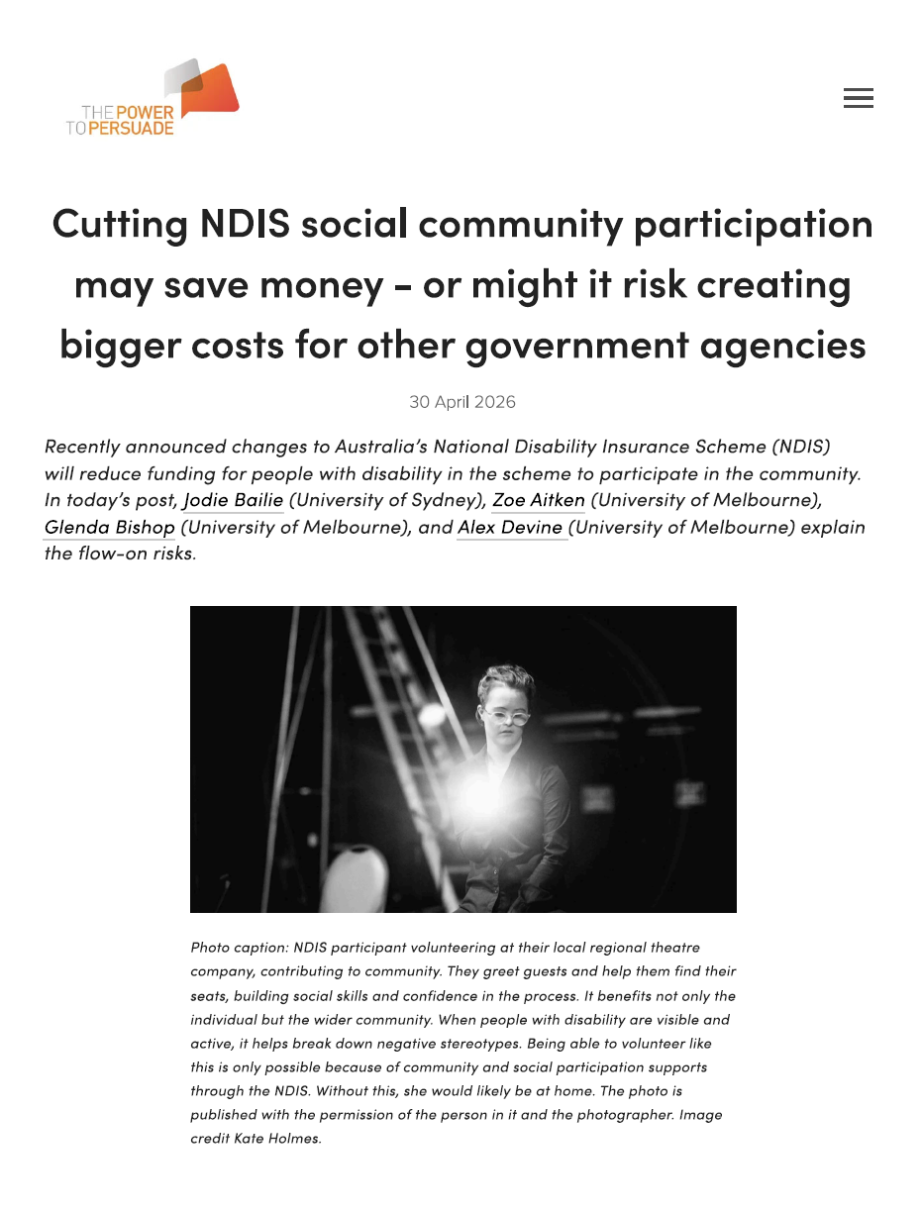
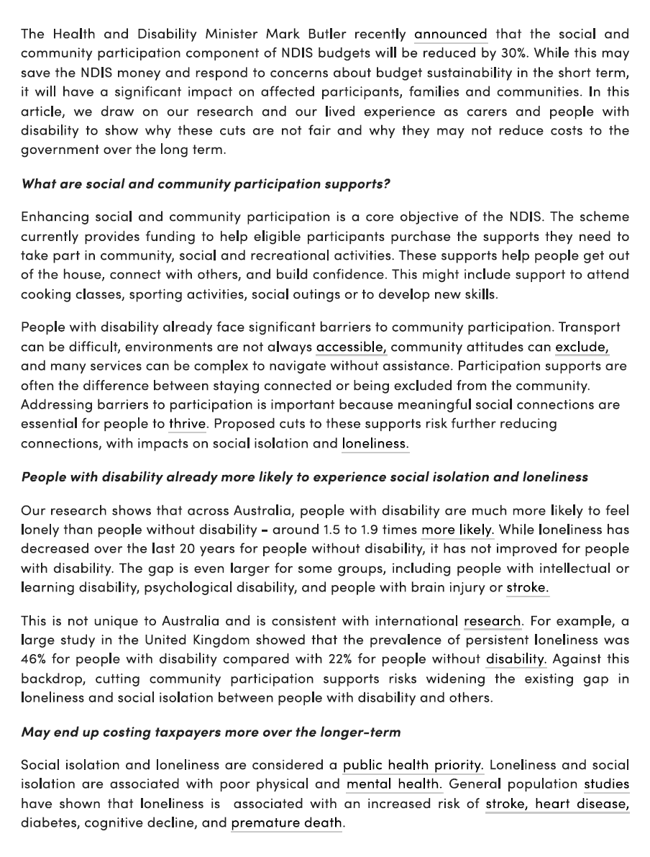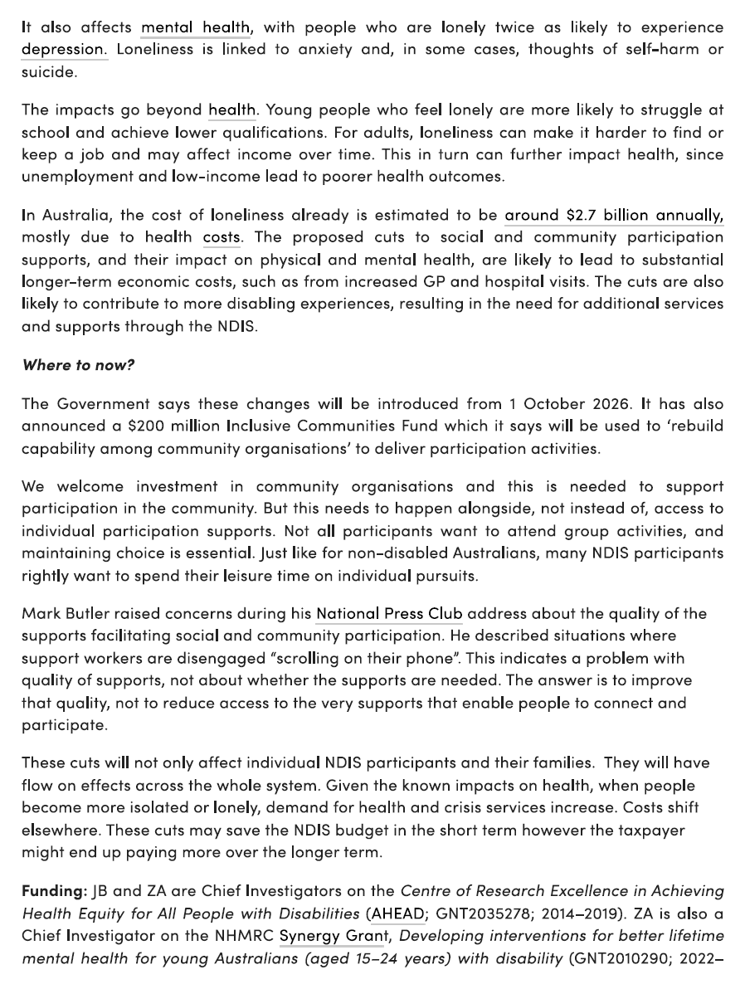

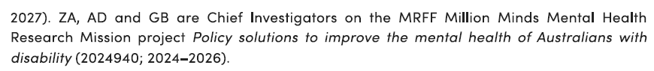


























Contact:
Deborah Begg
General Manager
02 9841 4444
deborah.begg@downsyndromensw.org.au

